A randomized experiment approach allows for the control of outside factors. A randomized experiment ensures the reliability of the observed results, that they result from the treatment – in this case, the Airbnb certification – because the expected difference between the control and treatment groups is only the Airbnb certification.

Scraping data from Airbnb’s website to analyze the effect of the Airbnb Plus certification on booking rate will lead to highly biased results because there is no control for other variables or factors that could lead to an increase in booking rates. Confounding variables would not be accounted for in this case.

**Descriptive statistics on the variables**

Prices for these two-bedroom one-bathroom listings went from $95 to $399, with a range of $304 and a median price of $209. The range between the first and third quartile for prices is $65.50. There are 36 unique price points (this shows many listing prices are similar).

Participants are unevenly balanced in terms of program. 3520 participants (39.64%) were in the MBA program while 5360 participants (60.36%) were in the MSBA program. Of the 8880 total impressions, 8103 properties (91.25%) do not have a Plus certification and 777 (8.75%) do.A screenshot of a computer

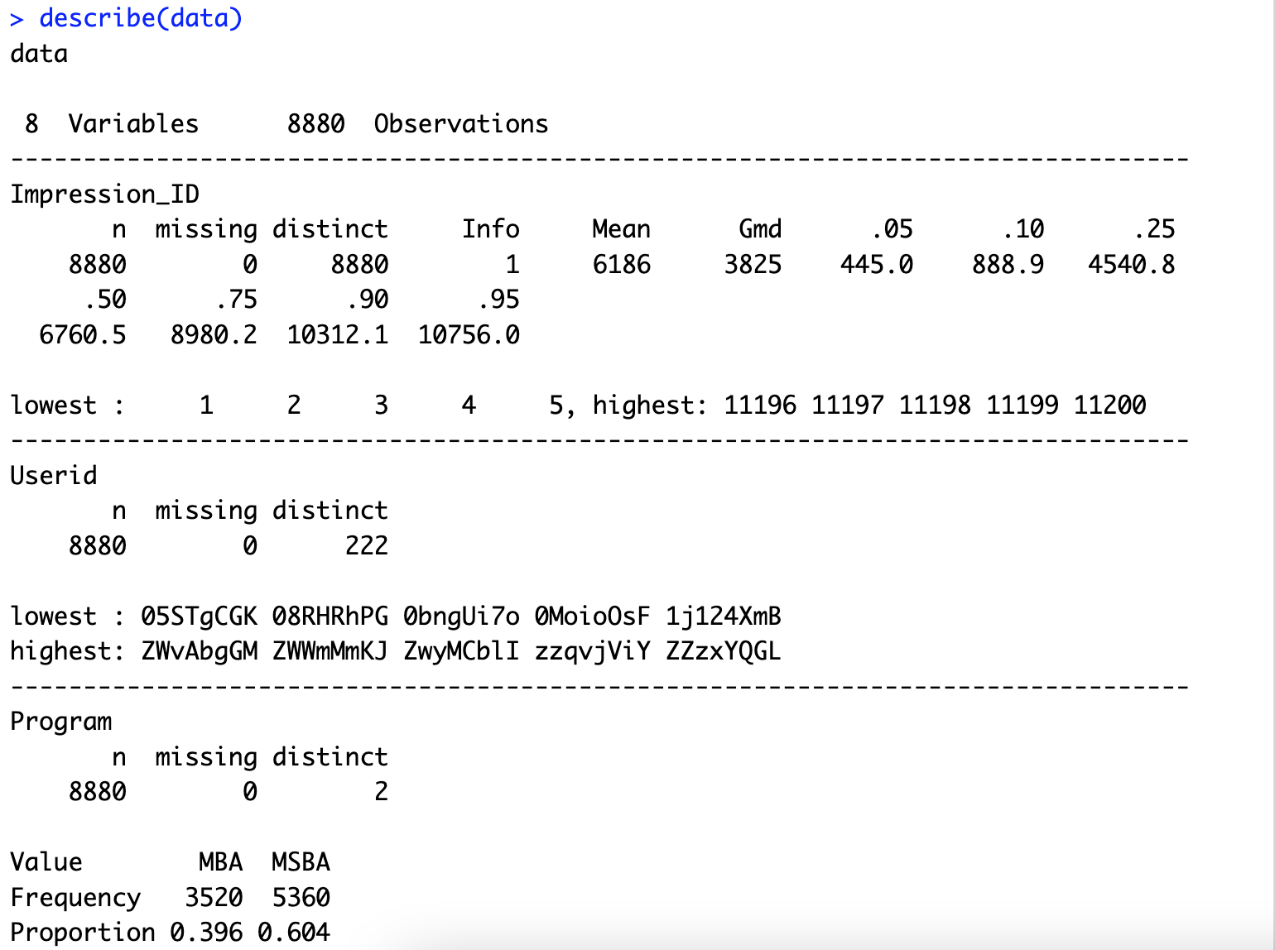

**Data visualizations**

This boxplot (box and whisker plot) of prices is a visualization that shows many property prices are similar. The listing highest in price is an outlier, illustrated outside of the box and whiskers with a dot ($399).

There is a slight difference in mean price of $13.91 between listings that were not booked and booked.

The difference in mean booking rate between a property without a Plus certification and one with a Plus certification is about 0.014.

**Logistic regression analysis, where the dependent variable is Booking and the independent variables are Plus, log(Rank), and log(Price)**

The results are interpreted as follows: On average, a unit increase in the Plus variable leads to an increase of 0.43005 units in Booked. As Rank increases by 1 percent, Booked decreases by 0.002112 (= -0.2112/100) units. A 1 percent increase in Price results in a 0.01119 (= -1.119/100) unit decrease in Booked.

For a 1 unit increase in Plus, the odds of a listing being booked (versus not being booked) increases by a factor of about 1.54. For a 1 unit increase in the log of Rank, the odds of a listing being booked increases by a factor of 0.81. For a 1 unit increase in the log of Price, the odds of a listing being booked increases by a factor of about 0.33.

**Result**

Holding all other variables constant at their mean values, a Plus badge (1 unit increase in Plus) will lead to about a 54% increase in the odds of a listing being booked.

The main takeaway from my analysis is that an Airbnb Plus certification by far has the largest impact on whether a property is booked or not. Another thing to note is that while ranking and price do influence booking, it is not nearly as much as a Plus badge does. A property owner debating whether the investment of money, time, and effort that goes into obtaining the Plus badge should know that the Plus certification does result in higher booking rates.